Exponential Function
Rule:
y = a(c)^{x} Where a = initial value / y-intercept
Where c = base / change
Where x = exponent / time

The formula can also be viewed as:
y = a(c)^{bx} Where b = # of time periods
y = start(change)^{time}
y = a (1± $\frac{percent}{100}$)^{x} Where + is used when the amount is increasing
Where – is used when the amount is decreasing

Finding the rule from a graph:
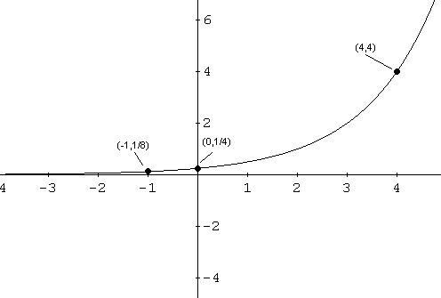

Step 1 – Identify the y-intercept / initial value
$\frac{1}{4}$ or 0.25
Step 2 – plug in initial value into base formula
y = a(c)^{x}
y = $\frac{1}{4}$(c)^{x}
Step 3 – plug in a given coordinate to solve for “c” value
Two options: (-1, $\frac{1}{8}$ ) or (4,4)
y = $\frac{1}{4}$(c)^{x}
4 = $\frac{1}{4}$ (c)⁴
$\frac{4}{\frac{1}{4}}$ = $\frac{\frac{1 }{4}(c)4}{\frac{1}{4}}$
Isolate the variable by diving both sides by the number in front of the variable
16 = c⁴
$\sqrt[4]{16}$ = c = 2

Therefore the rule is y = $\frac{1}{4}$(2)^{x}

Word Problems
- Today, a loaf of bread costs $3.49. If inflation averages 4% per year, then how much will a loaf cost in 50 years?
Step 1 – Identify what we know
- Initial value / start / a = 3.49
- Base amount / keep / c = 1 + 4%
- Exponent / time / x = 50
- Power / Answer / y = ????

Step 2 – Plug values into base formula
y = a (1± $\frac{percent}{100}$)^{x}
y = 3.49 (1+ $\frac{4}{100}$)⁵⁰
y = 3.49 (1 + 0.04)⁵⁰
Step 3 – Simplify and Solve. Remember to follow BEDMAS.
y = 3.49 (1.04)⁵⁰
y = 3.49 (7.10)
y = $24.80

- You buy a car worth $28000. If the depreciation rate of the car is 18% per annum, how much will the car be worth in 5 years?

Step 1 – Identify what we know
- Initial value / start / a = 28000
- Base amount / keep / c = 1 - 18%
- Exponent / time / x = 5
- Power / Answer / y = ????

Step 2 – Plug values into base formula
y = a (1± $\frac{percent}{100}$)x
y = 28000 (1- $\frac{18}{100}$)⁵
y = 28000 (1- 0.18)⁵

Step 3 – Simplify and Solve. Remember to follow BEDMAS.
Y = 28000(0.82)⁵
Y = 28000(0.37)
Y = $10360

- A certain strain of bacteria doubles every 6 hours. If a laboratory has 200 of these bacteria today, how many will there be in four days?

- Initial value / start / a = 200
- Base amount / keep / c = 2
- Periods $\frac{24 hours=1 day}{6 hours}$= 4
- Exponent / time / x = 4
- Power / Answer / y = ????
y = a(c)^{bx}
y = 200(2)⁽⁴⁾⁽⁴⁾
y = 200(2)¹⁶
y = 200(65536)
y = 13 107 200

- Each year the frog population of a small wooded area declines by 5% in contrast to the previous year. If this wooded area now has 2000 frogs, how many frogs will be present in 10 years time?
Answer
y = a (1± $\frac{percent}{100}$)x
y = 2000 (1- $\frac{5}{100}$)¹⁰
y = 2000 (1- 0.05)¹⁰
y = 2000 (0.95)¹⁰
y = 2000 (0.59)
y = 1180
- Initial value / start / a = 2000
- Base amount / keep / c = 1 - 5%
- Exponent / time / x = 10
- Power / Answer / y = ????

- Among the options available to finance a purchase, credit cards are the ones that have the highest interest rates. If Diane makes a purchase worth $1200 with a credit card that has an interest rate of 1.5% each month, how much will she pay in interest if she can only clear her card a year later?
Answer
- Initial value / start / a = 1200
y = a (1± $\frac{percent}{100}$)^{x}
y = 1200 (1+ $\frac{1.5}{100}$)¹²
y = 1200 (1 + 0.015)¹²
y = 1200 (1.015)¹²
y = 1200 (1.19)
y = $1434.74
- Base amount / keep / c = 1 + 1.5%
- Exponent / time / x = 12
- Power / Answer / y = ????

- Under laboratory conditions, a mosquito population triples every 4 hours. If the initial population was 200 mosquitoes, then how many would there be after 2 days?
Answer
y = a(c)^{bx}
y = 200(3)⁽⁶⁾⁽²⁾
y = 200(3)¹²
y = 200(531 441)
y = 106 288 200
- Initial value / start / a = 200
- Base amount / keep / c = 3
- Periods $\frac{24 hours=1 day}{4 hours}$= 6
- Exponent / time / x = 2
- Power / Answer / y = ????

