Equivalent Figures
Are these two lines equivalent – that is, are they the same? Why or why not.

10 cm
10 cm

Are these two figures equivalent? What makes them equal to each other?

10 m
3 m
5 m
3 m

Figures are equivalent when they have the same area.

A_{triangle} = $\frac{b • h}{2}$
A_{triangle} = $\frac{10 • 3}{2}$
A_{triangle} = $15$m²

A_{rectangle} = L × W
A_{rectangle} = 5 × 3
A_{rectangle} = 15m²

Are these two solids equivalent? What makes them equal to each other?
2 cm
2 cm
6 cm
2 cm
2 cm
2 cm

Solids are equivalent when they have the same volume

V_{cube} = s³ V_{pyramid} = $\frac{Ab • h}{3}$
V_{cube} = 2³ V_{pyramid} = $\frac{(2 •2) • 6}{3}$
V_{cube} = 8 cm³ V_{pyramid} = 8cm³

Example #1
Determine if these figures / solids are equivalent.
6
9
4
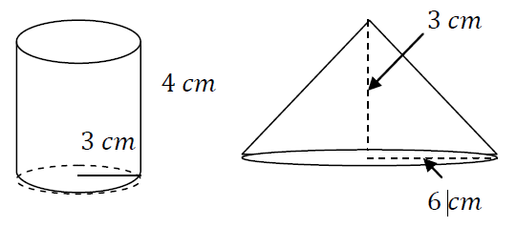

Example #2
A cone and a cylinder are equivalent. The radius and the height of the cone measure 6cm and 10cm respectively. What is the height of the cylinder if its radius measures 5cm?
Step 1 – Draw the solids and label their given dimensions
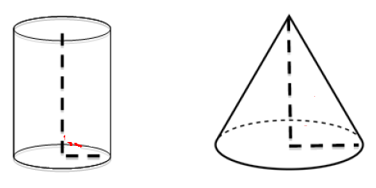
6cm
10cm
5cm

Step 2 – Given that they are equivalent (same volume) determine the volume of the shape with the most information (cone)
V = $\frac{πr^{2}•h}{3}$ V = $\frac{π6^{2}•10}{3}$ V = $\frac{π36 •10}{3}$ V = 376.99cm³
Step 3 – Plug the found volume into the formula for the other solid (given that they are equal) and work backwards to determine the missing measure
V = $πr^{2}•h$ 376.99 = $π5^{2}•h$ 376.99 = $π25•h$
376.99 = $78.5•h$ 376.99 = 78.5h $\frac{376.99 }{78.5}$ = $\frac{78.5h }{78.5}$ h = 4.8
Example #3
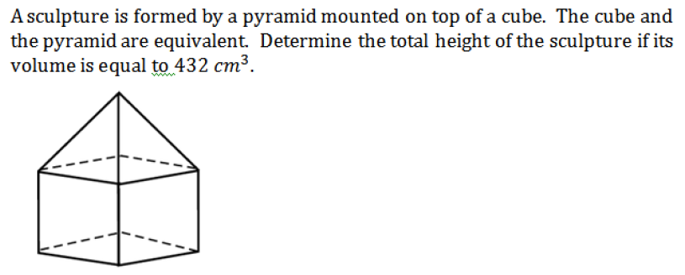

Example #4
A rectangular plot of land, with dimensions 45m by 20m, and a square plot of land have the same area. The cost, per meter of fencing, is $25. Which plot of land is cheaper to fence in?

Example #5
- The square and the triangle below are equivalent. What is the area of each figure if the perimeter of the square is 30cm?
- What is the length of the base of the triangle?

Example #6
Are the following solids equivalent?
12
10
10
40
20
8
5

Example #7
The sphere and the cylinder below are equivalent. Determine the radius of the sphere.
10
4

