**Polygon of Constraints**

* A polygon of constraint is a defined shape formed by the solution sets of a system of inequalities.
* 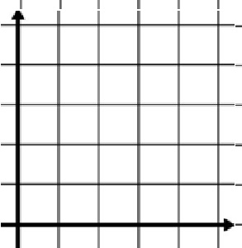The polygon can either be open or closed

Open Polygon



Closed Polygon

**Creating the Polygon**

x ≥ 0  
y ≥ 0  
x + y ≤ 7  
x ≥ 2  
y ≥ 2  
x ≤ 2y

**Step 1 – Put all inequalities into functional form (y=ax+b)**

x + y ≤ 7 y ≤ -x + 7

x ≤ 2y 2y ≥ x y ≥ $\frac{1x}{2}$

**Step 2 – Graph all the inequalities on the same Cartesian plane**

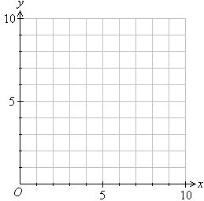

**Step 3 – Shade the common area for all inequalities**

**Determining the Vertices of the Polygon**

* The vertices are the corners of the polygon where the lines intersect
* The vertices can be found by solving the system of equation for each intersecting line (comparison method)
* A vertex belongs to the solution set only if the boundary line is a solid line. If it is a dotted line, it is not part of the solution set

Example:

x ≥ 0  
y ≥ 0   
-3x + 2y ≤ 1  
x + 7y ≥ 15  
4x + 5y ≤ 37

**Step 1 – Put all inequalities into functional form (y=ax+b)**

-3x + 2y ≤ 1 2y ≤ 3x + 1 y ≤ $\frac{3x}{2}$ + 0.5

x + 7y ≥ 15 7y ≥ -x + 15 y ≥ $\frac{-1x}{7}$ + $\frac{15}{7}$

4x + 5y ≤ 37 5y ≤ -4x + 37 y ≤ $\frac{-4x}{5}$ + $\frac{37}{5}$

**Step 2 – Graph all the inequalities on the same Cartesian plane**





**Step 3 – Shade the common area for all inequalities**

y ≤ $\frac{3x}{2}$ + 0.5

y ≤ $\frac{-4x}{5}$ + $\frac{37}{5}$

B

y ≥ $\frac{-1x}{7}$ + $\frac{15}{7}$

A

C

**Step 4 – Use a system of equation (comparison method) to determine each corner of the polygon of constraints based on which lines intersect to form the corners.**

y ≤ $\frac{3x}{2}$ + $\frac{1}{2}$& y ≥ +   
  
 + = +   
  
 + = -   
  
 =   
  
 =   
  
x = 1

Vertice A

y = $\frac{3x}{2}$ + 0.5 y = $\frac{3(1)}{2}$ + 0.5 y = $\frac{3}{2}$ + 0.5 y = 1.5 + 0.5 y = 2

ss = (1,2)  
  
Try to solve for B and C